Student name:

Student ID:

SIT123: Data Capture Technologies

# Lab Report Week 3: Using the Data Logger Shield in Arduino

In this task, we will learn about using an SD card to save sensor data.

## Pre-requisites: You must do the following before this task

1. **Watched the Lecture**
2. **Already done with Lab report of Week 2**
3. **Read** [**https://learn.adafruit.com/adafruit-data-logger-shield/using-the-real-time-clock**](https://learn.adafruit.com/adafruit-data-logger-shield/using-the-real-time-clock)
4. **Read this sheet from top to bottom**

## Task 1 - Objective

In this task, you will write a program to detect motion and save the detected motion readings to an SD card, using a data logger shield.

## Hardware Required

* Arduino Board
* USB cable
* SD Card (SanDisk 16Gb Ultra SDHC Memory Card)
* Data Logging Shield for Arduino
* CR1220 Coin Cell Battery
* HCSR505 PIR Passive Infra Red Motion Detector

## Task 1 - Submission Details

There are 3 questions in this task. Answer all of them in this word document itself and submit to unit site.

### **Q1. Follow the steps in “Setting Up The SD Card Activity Sheet”. At the end of activity, take a screenshot of the Serial Monitor and include here.**

### **Q2. Follow the steps in “Using the Real Time Clock Activity Sheet”.**

1. At the end of activity, take a screenshot of the Serial Monitor and include here.

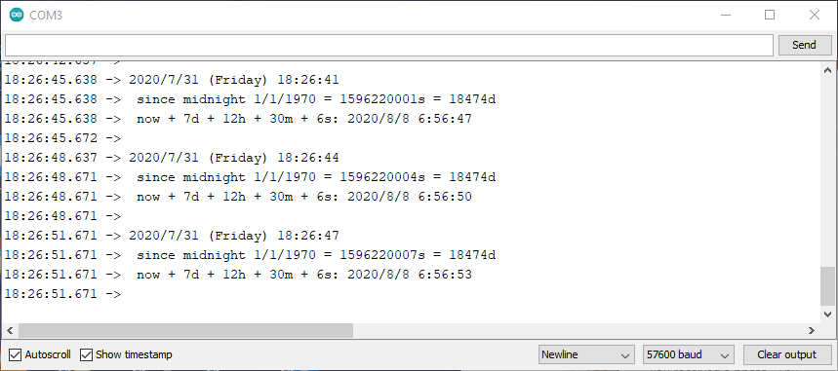

1. Examine the code. What does the following line of code do?

DateTime now = rtc.now();

(Hint: refer to <https://learn.adafruit.com/adafruit-data-logger-shield/using-the-real-time-clock> )

Returns the current date and time of day being reported by the logger

### **Q3. Now you are ready to start logging data to file! Follow the steps in “Saving Motion Data Activity Sheet”.**

1. At the end of activity, take a screenshot of the Serial Monitor and include here.
2. Run your program. Wave your hand in front if the motion sensor and observe the ‘Active’ state, then stop and wait until you see an ‘Inactive’ state on the Serial Monitor. Keep doing this for three minutes so that you get both ‘Active’ and ‘Inactive’ data. At the end of three minutes, unplug the USB. This will switch off the Arduino board. Next, retrieve the .csv file containing motion sensor data from the SD card. Upload the .csv file with this report to unit site.

## References

<https://learn.adafruit.com/adafruit-data-logger-shield/using-the-sd-card>

## Task 2 - Overview

Raw data is given in the Excel file. Explanation about the data in the Excel file is given in the data document file “Data document.pdf”.

We will be using the following key steps to execute this task.

Step 1 - Read the provided Data document and inspect the provided raw data in the Excel file

Step 2 - Calculate the time durations for each bathroom visit

Step 3 - Calculate descriptive statistics for the data set using Excel’s built-in functions, to find out some useful information about John’s bathroom usage, such as the average time he spends in the bathroom per visit.

## Step-by-step Instructions: Calculate the time durations for each bathroom visit

1. Open the provided Excel file. You are now going to use the given data to calculate time durations for each bathroom visit. To do this, first insert new sheet. Name it ‘CalculatedDurations’
2. Copy the two columns TIMESTAMP & STATE from the first sheet to the newly created sheet

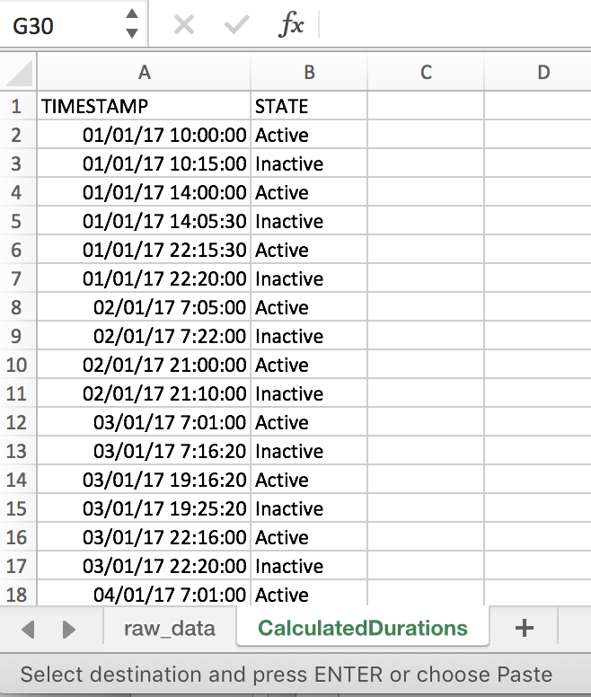

1. Add a new column with header ‘DURATION (MINUTES)’ to the right.

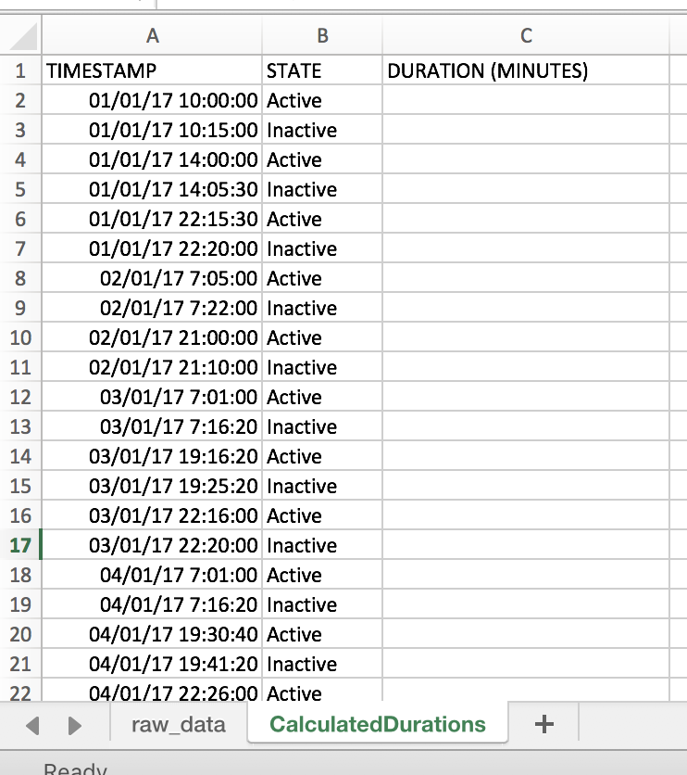

1. Now, what we want to do is to calculate how much time John spent in the bathroom per each visit. To do this, we need to find out the time difference between each ‘Active’ state and the next ‘Inactive’ state.

The first visit in the given data starts at 10 am and ends at 10:15 am. Let’s calculate the duration of this first visit.

The duration of the first visit is the time difference between 10:15 am and 10:00 am. To calculate this in Excel, we can write a simple formula.

Click on cell C3 and type the following:

=(A3-A2)

What is displayed is the time difference, but you’ll notice that it is not in minutes! To get the answer in minutes, you need to multiply this by 24 * 60. This is because there are 24 hours in a day, and 60 minutes to each hour. Modify the formula in C3 to be:

=(A3-A2) * 24 *60

Press Enter.

You should now see 15 as the answer. As you can see, the time difference between 10:15 am and 10:00 is indeed 15 minutes, so our formula is correct!

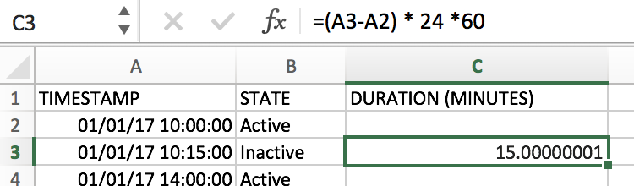

1. Now we need to apply this formula to all of the remaining rows in Column C. Select C3 and hover your pointer to the edge of the C3 cell until you see a cross hair. Then click and drag the pointer to the last cell in the range (C35)

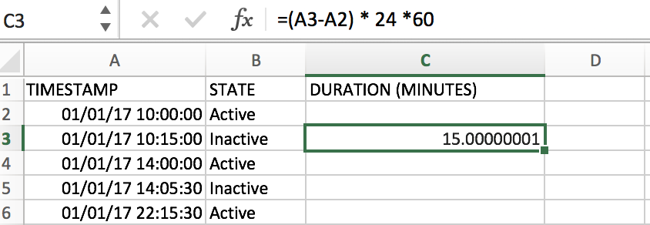

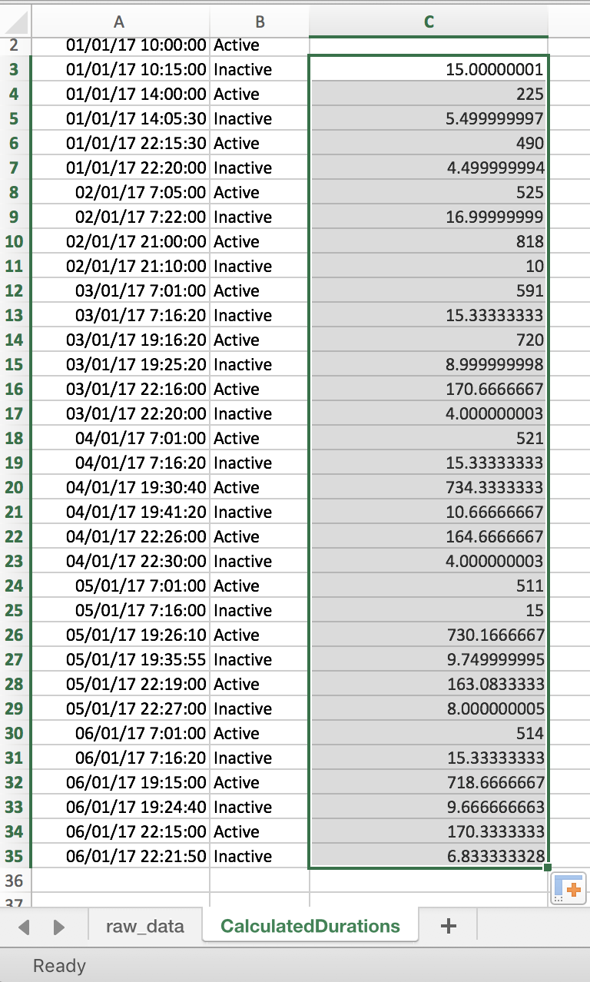

1. Now as you can see we have the active durations in Column C. But, the active durations should be, [Time motion stopped - Time motion started], or in other words [Time motion went inactive - Time motion went active]. But our formula in step 5 applied it to ALL rows. For example, look at the result in C4. That is [Time new motion started - Time previous motion stopped]. Now we need to filter these out, and only keep durations from [Time motion went inactive - Time motion went active].
2. Add a new column header named ‘ACTIVE DURATION (MINUTES)’ to the right.

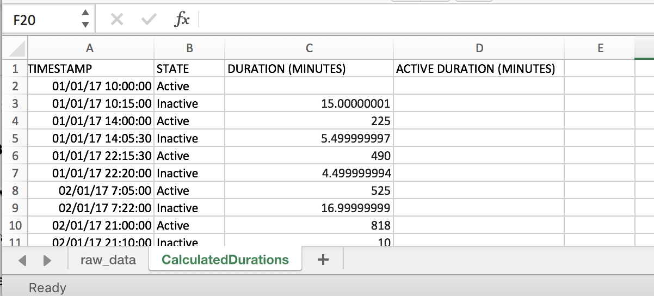

1. Of course, we can manually select which cells contain the Active Durations (time diff between Inactive - Active). But imagine if we had hundreds of rows! So we’re going to automate this by making use of Excel.
2. What we want Excel to do is to select the DURATION value from Column C if the corresponding row in Column B contains ‘Inactive’.

To do this, we write this as a formula. Type the following into D2:

=IF(ISNUMBER(FIND("Inactive",B2)),C2,"NULL")

Here the formula is saying, IF B2 contains ‘Inactive’, then use the value in C2, else, insert NULL

1. Apply the above formula to cells D2:D35

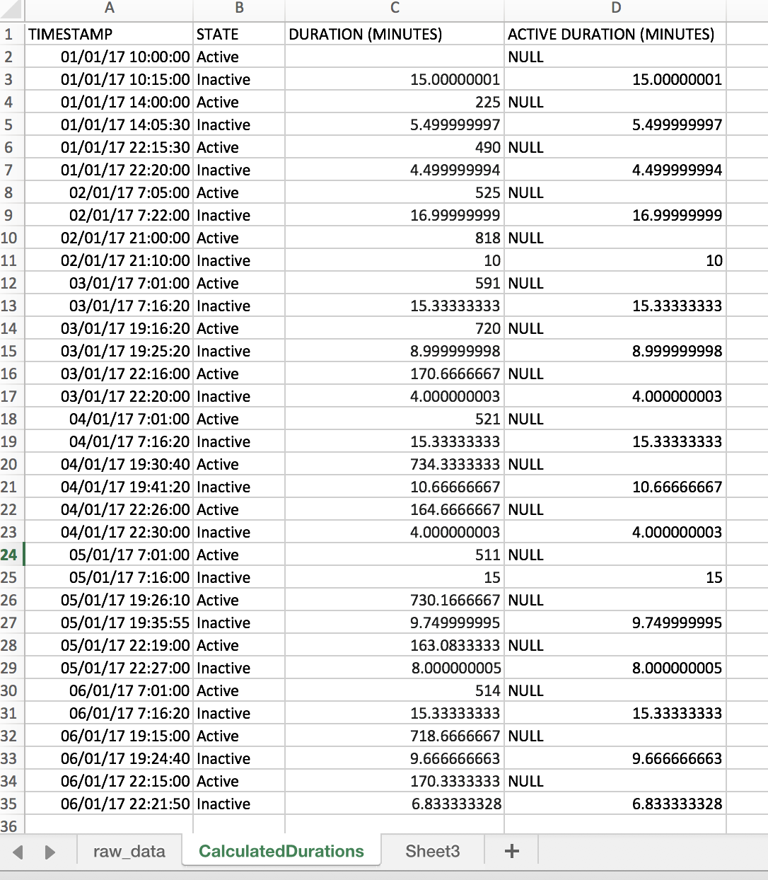

1. OK - now we have column D with only the active values, but now we’ve got NULL values which we need to filter out. Remember that our goal is to have a list of active duration values. We are going to filter these in the next step.
2. Click on D1, and on the Excel Ribbon, under ‘Data’, click on ‘Filter’

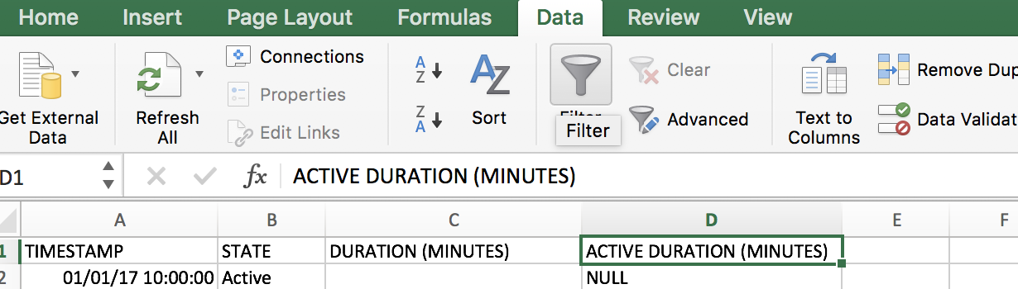

1. Now your column headers should show drop down arrows:

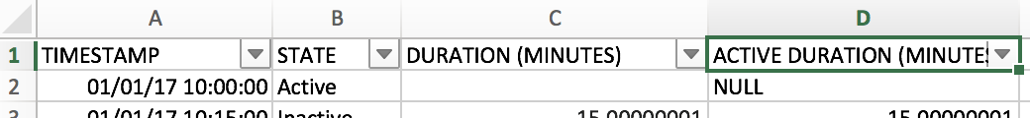

1. Click on the drop down arrow on D1. It will show a filter dialog box

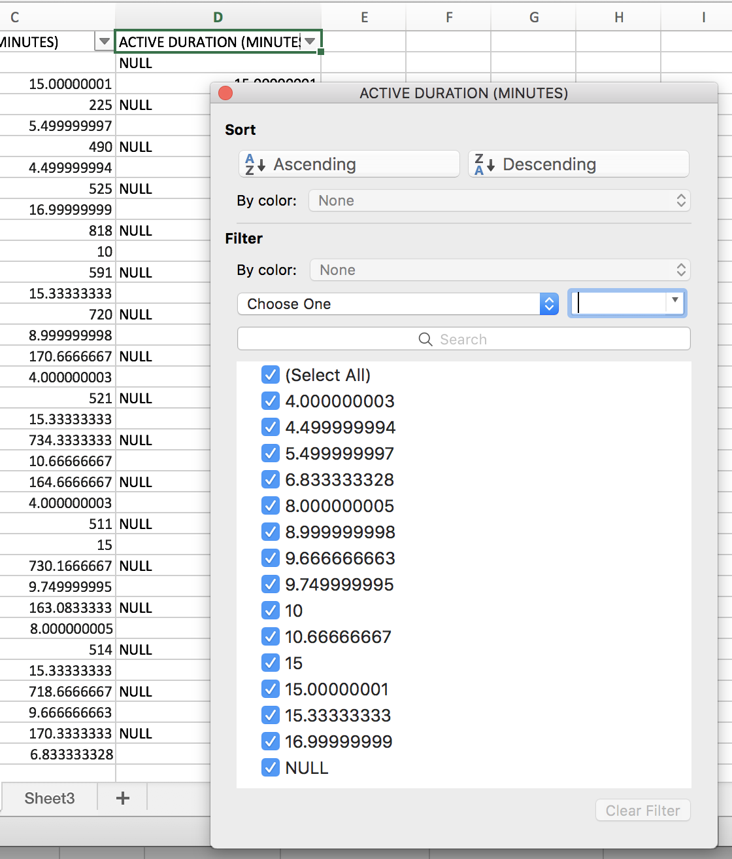

1. Untick the checkbox for ‘NULL’. This will immediately filter out the NULL values in Column D.

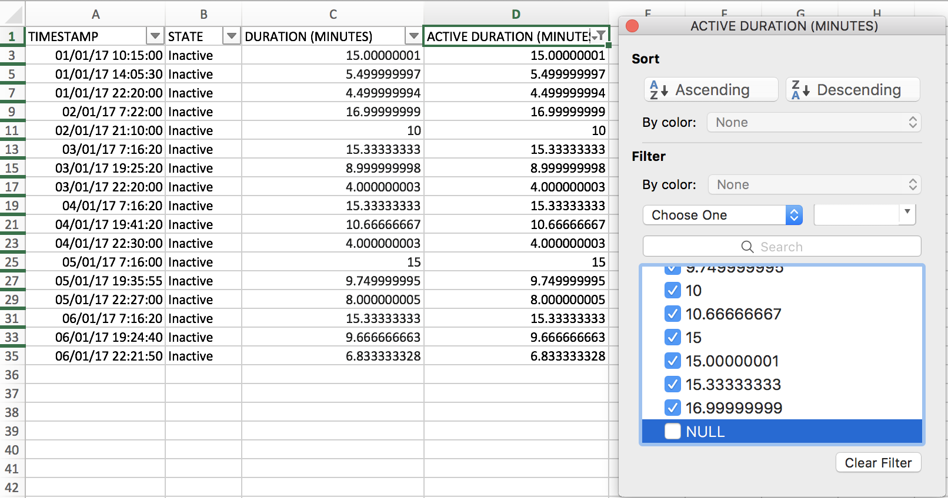

1. Have a look at column D. Now all the values that are displayed are the active durations for each bathroom visit!

## Step-by-step Instructions: Calculate descriptive statistics for the data set

1. First, create a new sheet named ‘Stats’, and copy-paste the filtered Active Duration values in column D, to the new sheet.

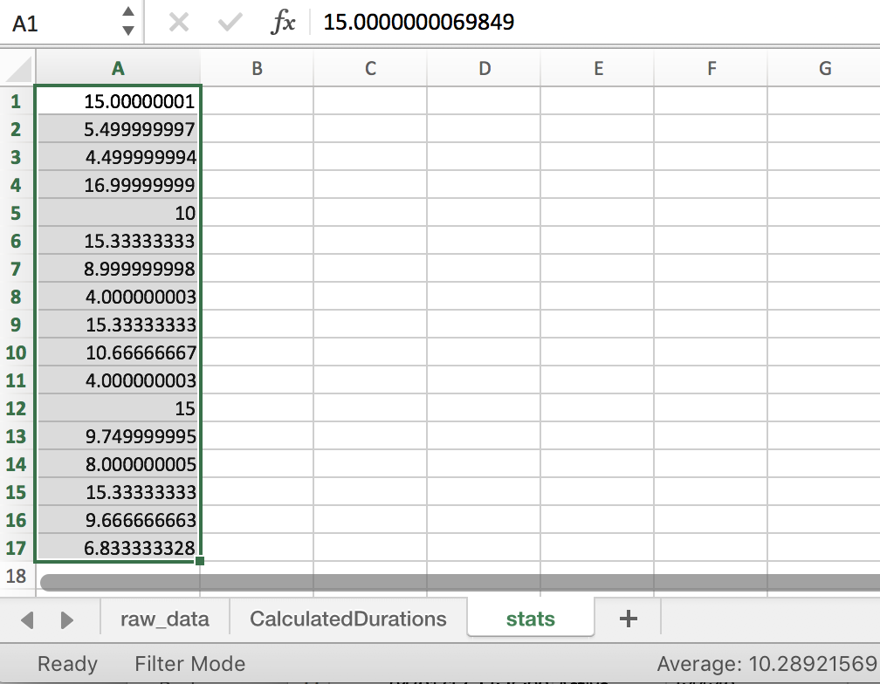

1. Next you need to turn on Excel’s Data Analysis Add-On. Follow the instructions here: <https://www.youtube.com/watch?v=mIoS7IRo36c>
2. Now, click on ‘Data Analysis’

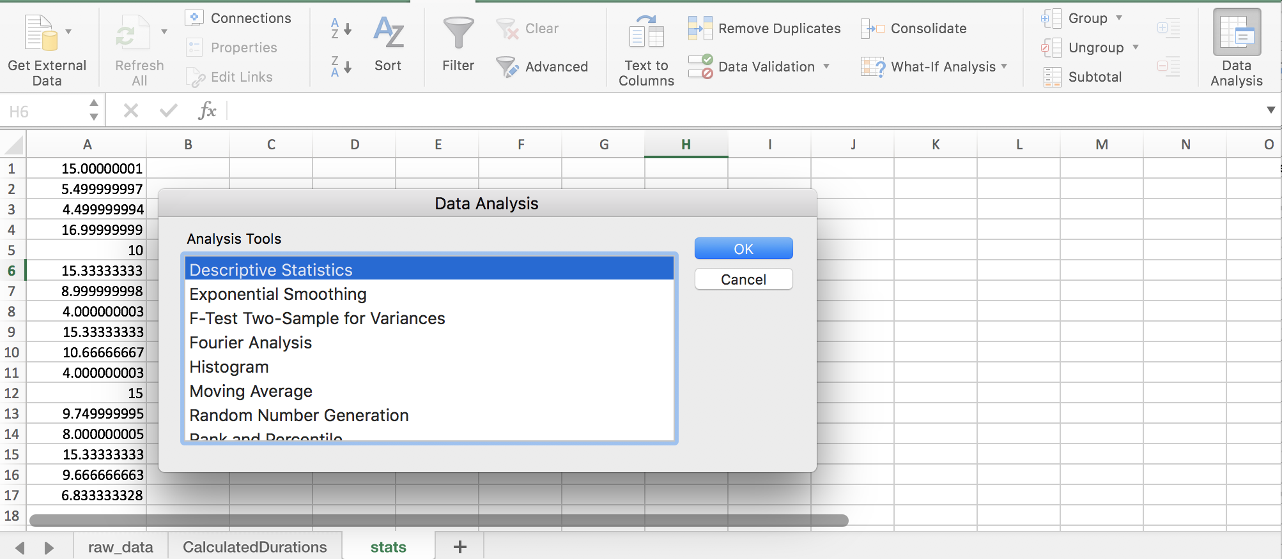

1. Select Descriptive Statistics and click OK.
2. Now, you will be shown the dialog box for Descriptive Statistics. Here, you need to select the following:
   1. Input range: this is the data range in column A
   2. Output range: this is cell range to add the descriptive statistics values
   3. Summary statistics

Type in the following values:

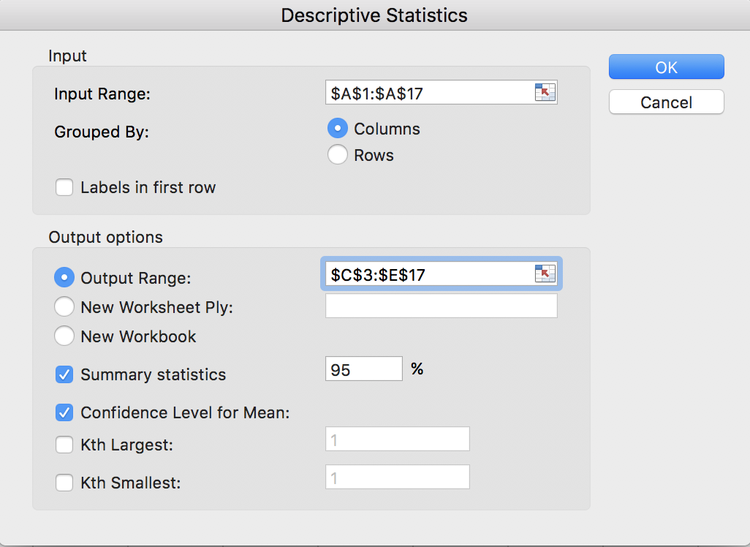

1. Click OK. Descriptive statistic values for the given sample should displayed as in the following screenshot:

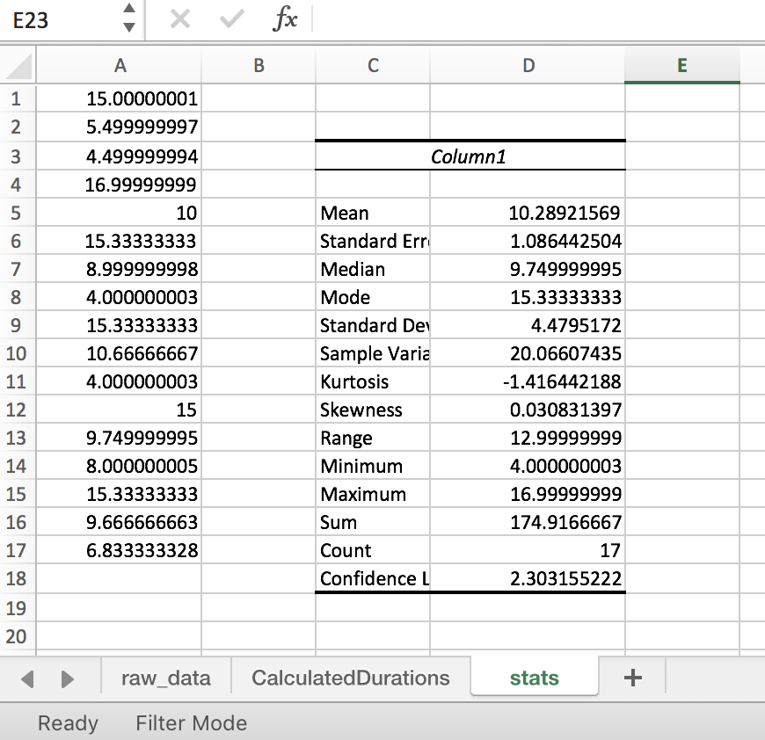

All done! Now we have some useful information about John’s bathroom usage.

## Task 2 - Submission Details

There are 2 questions in this task. Answer all of them in this word document itself.

### **Q1: Upload your completed excel workbook to unit site.**

### **Q2: Look at the calculated descriptive statistics. Fill in the below table explaining what each term means in terms of John’s bathroom usage. The first row has been done for you.**

|  |  |  |
| --- | --- | --- |
| Mean | 10.289 minutes | The average time John uses the bathroom per visit is 10.289 minutes. |
| Median | 9.75 minutes | The median time John uses the bathroom is 9.75 minutes |
| Mode | 15.33 minutes | The most common time John uses the bathroom for is 15.33 minutes |
| Standard deviation | 4.48 minutes | The amount of time John uses the bathroom for deviates by 4.48 minutes |
| Minimum | 4 minutes | The minimum time John uses the bathroom for is 4 minutes |
| Maximum | 17 minutes | The maximum time John uses the bathroom for is 17 minutes |
| Count | 17 times | John has used the bathroom 17 times |
| Sum | 164.92 minutes | John has spent a total of 164.92 minutes in the bathroom |

## References

<https://www.khanacademy.org/math/statistics-probability/displaying-describing-data#mean-median-basics>

<https://www.khanacademy.org/math/statistics-probability/displaying-describing-data/pop-variance-standard-deviation/v/range-variance-and-standard-deviation-as-measures-of-dispersion>

<https://www.lynda.com/Business-Skills-tutorials/Descriptive-statistics/550747/611825-4.html?org=deakin.edu.au>

## **Task 3**

## Software Required

A web browser

One of the following apps installed:

* Android: Geo Tracker <https://play.google.com/store/apps/details?id=com.ilyabogdanovich.geotracker&hl=en>
* iOs: myTracks <https://itunes.apple.com/au/app/mytracks-the-gps-logger/id358697908?mt=8>
* Microsoft: GPS Tracker free

<https://www.microsoft.com/en-au/store/p/gps-tracker-free/9nblgggz2w34>

You may install and try out any other app well as, as long as they can track GPS & export tracks to GPX format.

## Task Submission Details

There are 3 questions in this task. Answer all of them in this word document itself and submit to unit site.

### **Q1: Track a journey using one of the installed mobile apps. It is best if your tracked journey spans at least 5 kilometers. Export your track to GPX format and save the file to your computer. Upload your .GPX file to unit site.**

(You can email the .gpx file from your phone and download it to your computer)

### **Q2: Open a browser on your computer and go to** [**http://utrack.crempa.net/**](http://utrack.crempa.net/) **. Upload your .GPX file to the site and click Generate Report’. Take a screenshot and include here.**

### **Q3: What information can you see from the generated report?**

Note: depending on the app you used to record the GPS data, timestamps could be either in local time (that is AEST if you are in Melbourne) or sometimes it could be in UTC.

The information provided in the report is of the variations in elevation, speed, time and distance travelled while being tracked.